Newsletter copy to promote Modulr

Here are three short copy examples that will help promote Modulr – you’re free to use them in any newsletters you send out to your clients.
To accompany the copy, you might like to also use this banner we’ve designed for you. See the link to Canva below for the banner itself – you can edit it and drop in your own practice logo if you wish. Just below the link is a screenshot that includes some instructions and guidance.
https://www.canva.com/design/DAEkKummVk8/U_10yOR1y0UhT9F11kAIWQ/edit

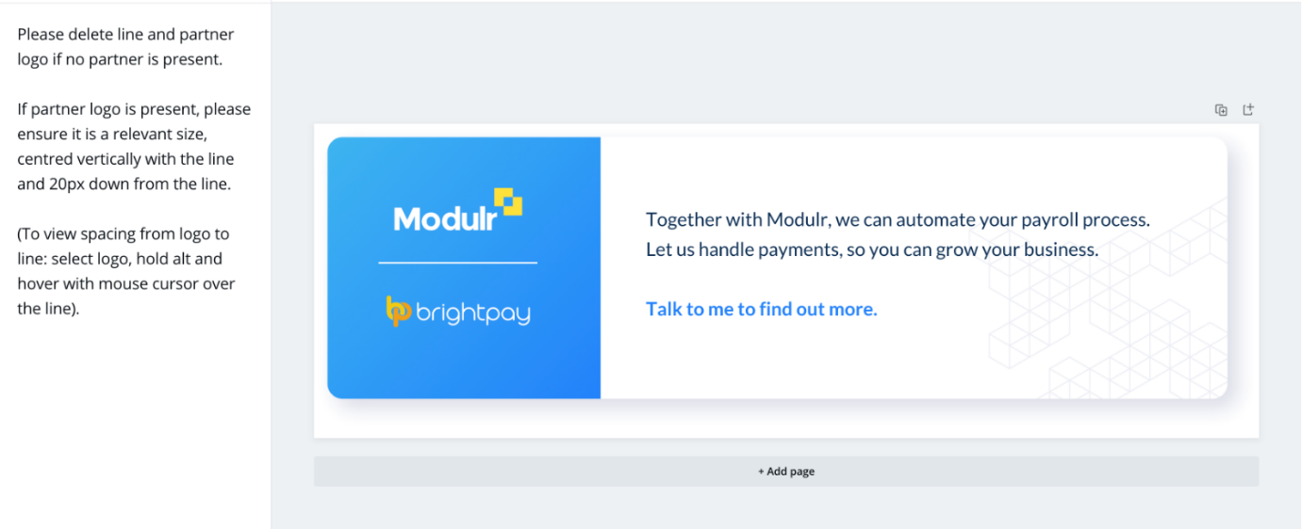
[1]
“As a small business owner, you know how much of a headache paying employees can be. With Modulr, your accountant can take payroll off your hands – preparing and managing all payments securely. Not only will it save you time – it takes the pressure off them, too. Modulr automates workflows so they can focus on delivering to you the best, most seamless customer service. Want to find out more? Get in touch.”
- Embed hyperlinks in the suggested words from the above text:
- “automates” https://www.modulrfinance.com/small-business/payments-dashboard
- “more” https://www.modulrfinance.com/small-business
[2]
“If your accountant is already doing your payroll preparation, but you’re still manually uploading payments to online banking, then it might not feel like your workload is any lighter. With Modulr you can automate your payroll process – no more getting bogged down with admin, and you’ll eliminate the risk of making mistakes. Contact us to learn more.”
- Embed hyperlinks in the suggested words from the above text:
- “automate” https://www.modulrfinance.com/small-business/payments-dashboard
- “more” https://www.modulrfinance.com/small-business

[3]
“Making sure your employees get paid on time, every time, is critical. But the admin involved is complex and stressful. With Modulr, your accountant can prepare payments securely on your behalf – all you have to do is approve in a few clicks before getting back to doing what you love: growing your business. Interested to learn more? Drop us a line.”
- Embed hyperlinks in the suggested words from the above text:
- “Modulr” https://www.modulrfinance.com/small-business/payments-dashboard
- “more” https://www.modulrfinance.com/small-business

